Cycadeoideales: Introduction, Classification and Features

Introduction to Cycadeoideales:

The Cycadofilicales, they formed the dominant fossil plants during Palaeozoic age. The Cycadofilicales have of course definite affinities with the cycads on one side and ferns on the other, but they had no cones either in the male or in the female part of the plants, so some workers think that the Cycadofilicales form a separate group quite distinct from gymnosperms.
In the Mesozoic times, however, we came across fossils plants which had cones and were definitely related to gymnosperms. So in Mesozoic the Cycadofilicales were replaced by true gymnosperms which formed strobili, and the seeds had a naked dicotyledonous embryo in them. The ovule or the seed was never enclosed in closed carpel.

The Mesozoic gymnosperms can be placed into two separate groups:
1. Cycadeoidales (Bennettitales) and
2. Cycadales.
Pant (1957) has placed the cycadeiods in a distinct class, the Cycadeoideopsida of the division Cycadophyta.
The Cycadeoideales (Bennettitales) first appeared in the Permian they reached their highest range during the Jurassic period, after which they disappeared altogether.
The second group Cycadales had a world-wide distribution during the Mesozoic period Majority of them had altogether disappeared; only a few types have been left which are confined to special parts of the East. The present day cycads are only the remnants of very large dyeing out group, i.e., they are sometimes described as living fossils, because they are on their way to extinction.
The Cycadeoideales (Bennettitales) were very much like the cycads in their general appearance, and as the Mesozoic had these two prominent groups of gymnosperms, so that period sometimes described as age of cycads.
These Cycadeoideales are closely related to the Cycadofilicales on one side and to cycads on the other but they have their own characteristic features which distinguish them from all other gymnosperms except the Gnetales. The important feature which separates the Cycadeoideales from other gymnosperms is the presence of bisporangiate strobili.
The plants of this group were diversified in their habit. Some types had short columnar stems like most of the living cycads. The short columnar stem was usually un-branched and at the apex of the plant there was a terminal crown of leaves which in most cases pinnate. Some other forms had branched stems with multiple crown.
In present day cycads we know that young leaves and megasporophylls are covered up by unicellular hairy outgrowths known as ramenta.
In Cycadeoideales (Bennettitales) these ramenta were not unicellular; they were scale like, flattened and were several cells in breadth. Like cycads the plants had well organized strobili or cones, but in cycads they are monosporangiate whereas in Cycadeoideales they were usually bisporangiate and they were either terminal or axiarlly in position.
Majority of Cycadeoideales (Bennettitales) seem to have flowered only once in their life and after flowering the plant died out as we find in some of present day angiosperms.
Classification of Cycadeoideales:

According to Sporne (1965), the order Cycadeoideales (Bennettitales) has been divided into three families.

They are:
1. Cycadeoideaceae.
2.Williamsoniaceae, and
3. Wielandiellaceae.
Here Cycadeoidea (Bennettites) of Cycadeoideaceae and Williamsonia of Williamsoinaceae have been discussed in detail.

Systematic Position of Cycadeoideales:
Gymnosperms
Class. Cycadopsida
Order. Cycadeoideales
Family. Cycadeoideaceae
Genus. Cycadeoidea
Bennettites, by American workers have been described as Cycadeoidea.

Features of Cycadeoideales:

(A) Morphological features::
In Cycadeoidea the stem was un-branched with a single crown of pinnate leaves at the tops, but some species had branched stem with a multiple crown. In some the stem was tuberous. In all cases the stem was covered up by persistent leaf bases as we find in Cycas.
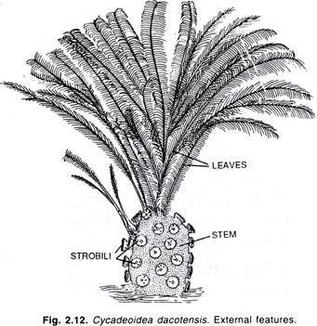
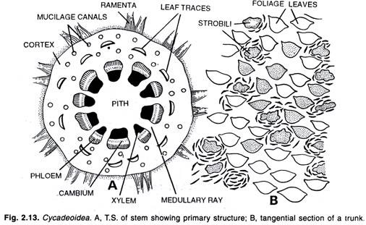
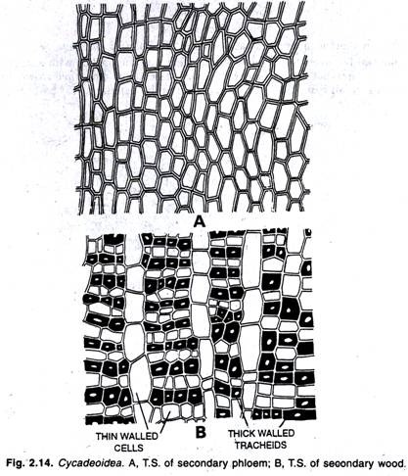
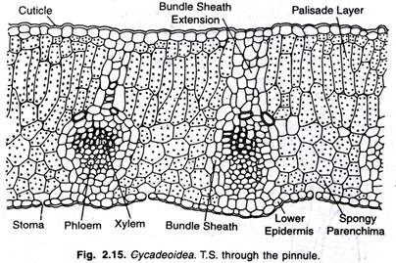
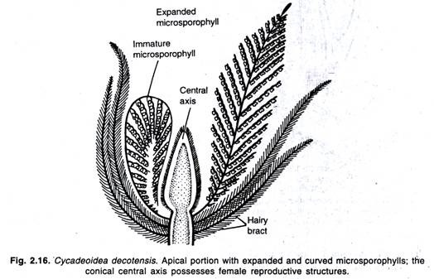
(B) Anatomical Features:
In structure the stem usually had large pith and thin vascular cylinder in which the protoxylem was endarch, thick cortex with a number of gum canals in it. There was small amount of secondary growth. Growth rings were only in few cases where the cambium persisted and was more active, so on the whole the stem anatomy was like those of present day cycads i.e., with large pith, broad cortex and narrow vascular cylinder.
In some few cases, however, the vascular cylinder was sufficiently broad. In the stem there were no traces of mesarch vascular bundles which is a common feature of leaf traces of present day cycads.
Another distinction from cycads was that the leaf traces were direct and no girdles while in present day cycads the girdling of leaf traces is quite common. The xylem had scalariform thickenings; pitted thickenings rather rare. This is an unusual feature because in the xylem of Cycadofilicales pitted thickening was very common and the group is much older than Cycadeoideales (Bennettitales).
The feature can only be explained that it was case of reversion.

Leaves of Cycadeoideales:
The leaves in Cycadeoidea (Bennettites) were large pinnate and showed xerophytic features. The vascular bundles in petiole and leaflets were mesarch with a strong sheath of sclerenchyma around it. Bipinnate leaves were rarely found in Cycadeoidea so the form and structure of leaf is practically like that of living cycads.

Fructification in Cycadeoideales:
The fructification in Cycadeoidea was bisporangiate. The strobili were developed in the upper part of the plant in large numbers. In some cases each leaf seems to have an axillary strobilus.
The whole of the strobilus and the bases of leaves were covered up by large sized scales which were several cells in breadth and sometimes more than one cell in thickness; strobili so were axillary and borne at the tip of axillary stalk or peduncle and therefore, these strobili can be described as dwarf branches.
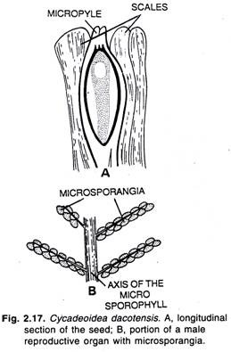
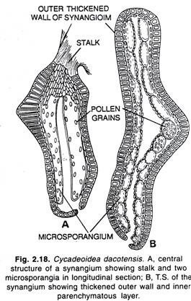
Each strobilus was made up of a number of heavy imbricate reduced leaves or bracts. These bracts completely surrounded the strobilus when it was the earliest stage of development where the strobilus developed these imbricate bracts separated and the inner part of the strobilus exposed.
The second whorl was made up of a number of leaf like microsporophylls, all of which were united at the base to form a cup-shaped structure round the central part of strobilus. The third central portion was hemispherical or dome-shaped in appearance. The central part was made up of a number of ovulate sporophylls. These megasporophylls were simply stalked.
At the tip of the stalk was developed an ovule. Some stalks were sterile and the tips of sterile stalks were flattened. The central stalks stood up vertically upward and they were longer in length.
The lateral ones continue to decrease in size from above downwards and stood projecting from lateral side, so the ripe female portion of strobilus hemispherical or dome-shaped in appearance. It is clear that in this bisporangiate strobilus the stamens or microsporophyll’s ripe first at which time the ovules were immature.
When the ovules matured the stamens were shed, so in the strobilus in which the ovules were ripe the microsporophyll’s were absent but in young strobilus both were present.
The microsporophyll’s or the stamens were 10 or 20 in number. These microsporophyll’s or stamens were all united at the base and each stamen was pinnate in form and on each stamen there were about twenty slender pinnae on either side, under the pinnae were developed two rows of fused sporangia or synangium had a short stalk and two pollen sacs in it; so each stamen was pinnate in form and was very much like the Marattious ferns in which we know the sporangia fuse to form synangia.
When stamens were very young they rolled downwards; so on the whole we can say that the stamens of Cycadeoidea (Bennettites) were very much like those of ferns, while in living gymnosperms they have lost their resemblance with the ordinary ferns.
The central portion was dome-shaped in form and this part was made up of a number of slender stalks, the central ones were long and stood vertically upwards, the lateral ones short and they diverged outwards. On the whole the female part was oblong in shape. Some of the stalks bore ovules while the others were sterile and their tips were expanded.
The male and female parts of strobilus were separated by the presence of some sterile bracts or scales. The ovule was orthrotropous and terminal. It was small in size and was surrounded by three-layered testa like that of Cycas. The nucellus was spearate from integuments only in the upper part the integument projects forward to form a long micropyle.
At the base of the micropyle the nucellus projected to form nucellus beak and round the base of nucellus beak there was a depression, the pollen chamber.
On the outside of the ovule there was a small basal cup which suggests the cupule of Lagenostoma, but it was much reduced in size and never surrounded the whole of ovule or seed at any time.
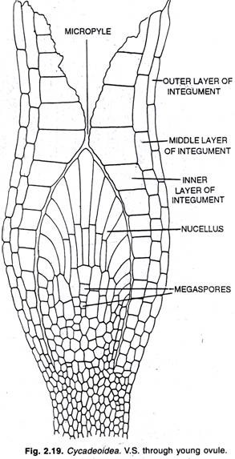
The ovule seems to fertilize by swimming sperms. After fertilization the ovule developed into a dicotyledonous embryo which was non-endospermic. When the seeds were developed the whole of the female part of strobilus became fleshy and formed a fruit.
In ripe fruit holes were present on the surface and at the base of these holes was dicot embryo while the fleshy portion of fruit was formed by stalk and interspersed sterile scales.
During the development of seed it appears that there was no suspensor developed. It might have been developed in the earlier stages of development of seed, but it is doubtful, so Cycadeoideales (Bennettitales) differ from other gymnosperms in these two important respects- 1. The non-formation of suspensor and 2. The presence of a non-albuminous dicot embryo.
